1. Download JMeter from the site. Select the zip file option. <https://jmeter.apache.org/download_jmeter.cgi>

1. Extract the zip file, place it at location you want to install

1. Run the file /bin/jmeter.bat to start JMeter in GUI

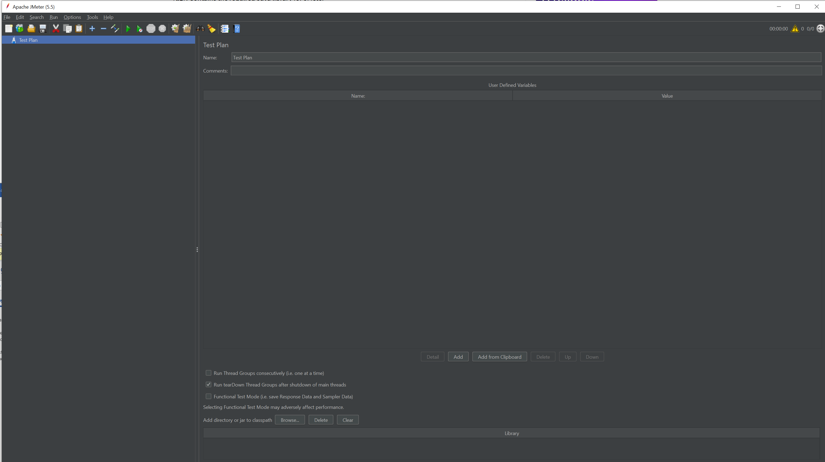

1. Load the test plan

1. Options: View Results Tree – if you want to view the complete HTTP request and response, useful for debugging.
2. To do the load test, open command prompt, cd to the /bin directory, and run the following command:

jmeter -n -t <test plan directory> -l <result file directory> -e -o <html folder>

the result file (csv) and html folder must be non-existent or empty